Participating at the Harvest Faire at the Crailo Historic Site in Rensselaer,NY.  Service to America:  DAR members volunteer millions of service hours annually in their local communities including supporting active duty military personnel and assisting veteran patients, awarding thousands of dollars in scholarships and financial aid each year to students, and supporting schools for underserved children with annual donations exceeding one million dollars. |  |  | About Us:  The DAR, founded in 1890 and headquartered in Washington, D.C., is a non-profit, non-political volunteer women's service organization dedicated to promoting patriotism, preserving American history, and securing America's future through better education for children.  Contact Us:  Web: http://fortcrailoDAR.weebly.com/  Fort crailo chapter, NSDAR  Rensselaer, NY 12144 |  |  | Fort crailo chapter, NSDAR  - National Society of the Daughters of the American Revolution

Planting at the Knox Monument in Rensselaer, NY  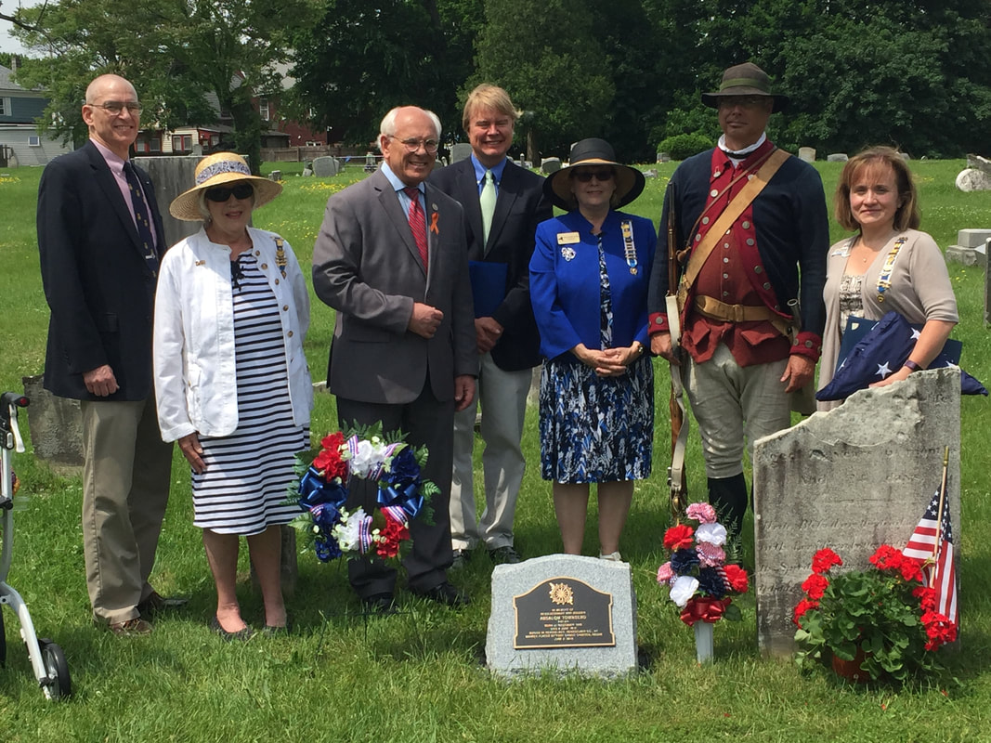  Memorial Dedication in Beverwyck Cemetery, Rensselaer. NY  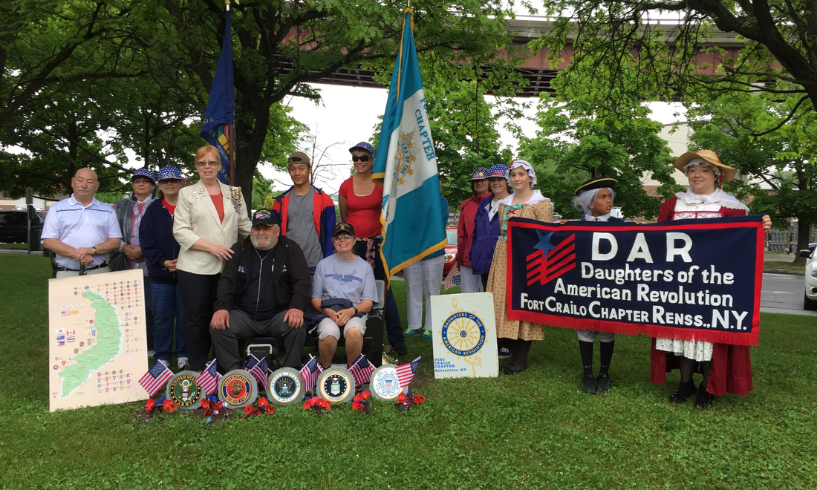  Vietnam Veterans Memorial Dedication |  |  | Eligibility:  Any woman 18 years or older, regardless of race, religion, or ethnic background, who can prove lineal descent from a patriot of the American Revolution.  There are 180,000 members with  3,000 chapters in all 50 states and Washington, D.C.; International chapters in Australia, Austria, Bahamas, Bermuda, Canada, France, Germany, Guam, Italy, Japan, Mexico, Russia, Spain, United Kingdom. More than 950,000 women have joined the DAR since it was founded.  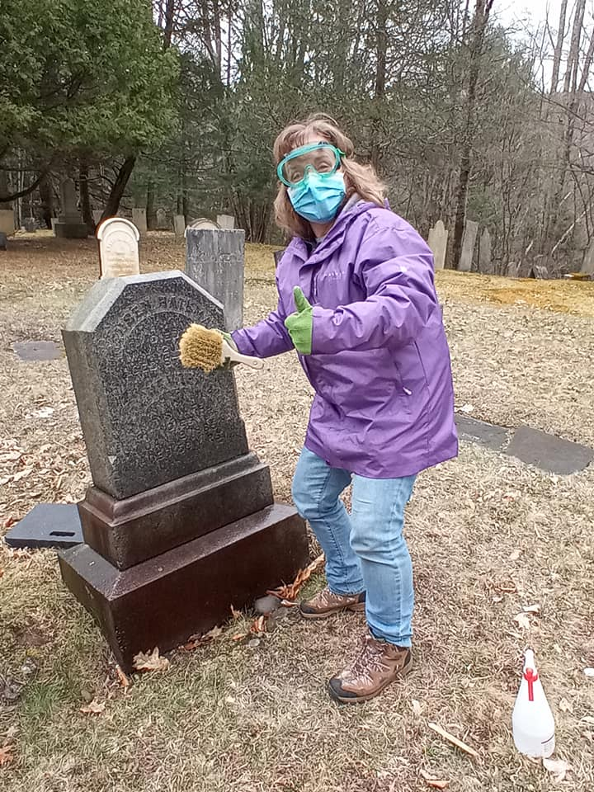  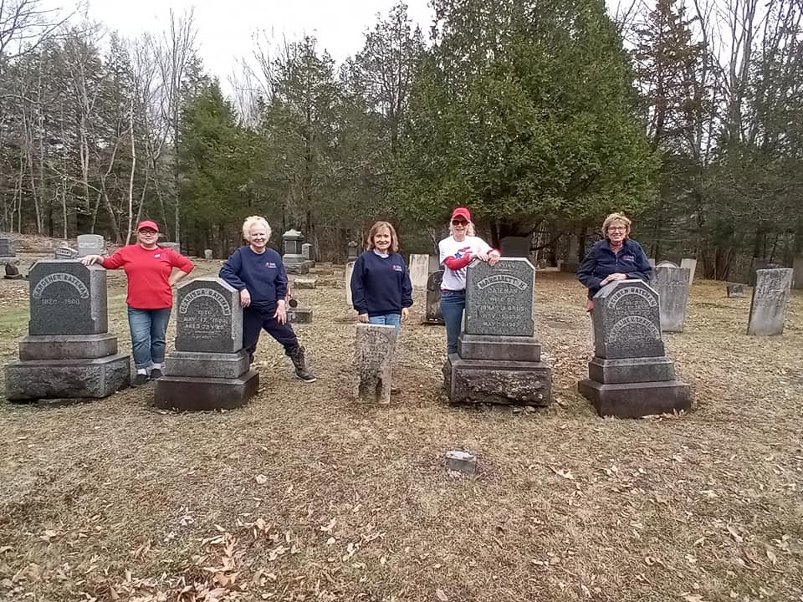  Cleaning Cemeteries, East Nassau, NY |  |  | 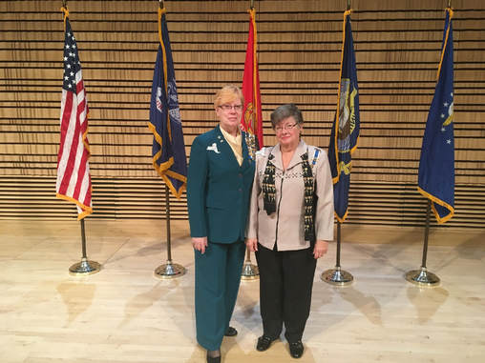Attending ROTC Awards at RPl, Troy NY  Our Chapter History  On December 23, 1933, the 176th chapter in New York was organized at the Fort Crailo Historic Site in Rensselaer. State Regent Mrs. Hamilton Gibbes gave the oath of office to the new officers. Ruth Electra Schaefer presented the new chapter with a gavel made from the wood of the battleship, Revenge, which saw nine days of actions on Lake Champlain during the American Revolution. The gavel is still used today at meetings.  Fort Crailo turned out to be a "war baby" with the early members holding many events to raise funds for the World War II effort. They donated to the Red Cross, Guide Dogs for the Blind, and to the "Metal Locator" fund. We were one of the four chapters to host the 48th state conference in 1943, which was stated by Vice President General Mrs. George Duffy to be "one of the finest state conferences . . . attended." Since 1940, Fort Crailo has been recognized for its efforts in, history, genealogy, and participation in the National All American Chorus.  As a chapter, we strive to uphold the NSDAR motto of "God, Home, and Country" through our programs, activities, and participation in the community.

